University of Surrey Net Zero Carbon Plan (NZC) for Scope 1 & 2 Emissions: 2025-2030

**Introduction**

The University of Surrey is committed to achieving **Net Zero Carbon for Scope 1 & 2 emissions by 2030**. This plan outlines our pathway to deliver substantial carbon reductions through strategic energy demand reduction, decarbonisation of energy supply, and behavioural change. While this document focuses on Scope 1 & 2 emissions, a complementary strategy for Scope 3 emissions and a Climate Adaptation and Resilience Plan (CARP) will be developed by 2025.

The plan aligns with Sustainable Development Goals (SDG) 13 (Climate Action) and 7 (Affordable and Clean Energy) and reflects national and global legislation for carbon reduction, while supporting the broader transition to a low-carbon society.

**2. University of Surrey Carbon Emissions Overview (2022/23)**

* **Scope 1 (Gas)**: 7,926 tonnes CO2e (43,414,898 kWh)
* **Scope 2 (Electricity)**: 6,910 tonnes CO2e (33,841,148 kWh)
* **Scope 3**: 68,950 tonnes CO2e (82% supply chain; remainder travel)

**Target**: Reduce Scope 1 & 2 carbon emissions to net zero by 2030, primarily by cutting energy demand and decarbonising heat by shifting to renewable sources.

**3. NZC Framework for Scope 1 & 2 Emissions**

Our strategy is built around the **8-point NZC framework** (see appendix one for visual representation), addressing both energy demand reduction and the decarbonisation of energy supply. These actions will work in parallel, with each contributing toward a robust carbon reduction trajectory.

**3.1 Reducing Energy Demand (Target: 50% Reduction)**

1. **Optimising Space Utilisation** (5% reduction)
   * **Goal**: Match space demand to actual usage, minimising wasted heating, cooling, and lighting.
   * **Targets**:
     + **Space utilisation** improved by 10% by 2027.
     + **5% reduction** in Scope 1 & 2 emissions by 2028.
   * **Actions**:
     + Implement an **AI-driven smart scheduling system** by end 2026 to monitor and optimise space usage in real time.
     + Conduct **live space audits** annually from 2025 to continuously improve space efficiency.
     + Adapt and review space norms for different types of space, teaching, research, private study, social and administration by 2027.
2. **Efficient Operational Control** (20% reduction)
   * **Goal**: Reduce energy waste by optimising controls for heating, ventilation, air conditioning (HVAC), and lighting systems. Control of this sort will have the best cost returns as well as carbon emission reductions.
   * **Targets**:
     + **20% reduction** in carbon and associated emissions by 2027.
   * **Actions**:
     + Establish an internal **Carbon Reduction Team** by 2024, working with facilities, capital projects, and building management.
     + Deploy **Building Energy Management Systems (BEMS)** with AI-based predictive control by the end of 2026.
3. **Energy Efficiency Investments** (20% reduction)
   * **Goal**: Retrofit inefficient buildings with the latest energy-efficient technologies.
   * **Targets**:
     + **20% carbon emissions reduction** by 2030 from retrofits.
     + Complete implementation of major energy efficiency measures by 2028.
   * **Actions**:
     + Audit the **top 20 carbon-emitting buildings** by 2026, covering 70% of emissions, and identify cost-effective energy-saving measures (e.g., LED lighting, HVAC upgrades).
     + Prioritise the installation of **LED lighting, insulation, HVAC system upgrades**, and smart controls across campus by 2028.
     + Look at replacing inefficient laboratory equipment from 2025 onwards.
4. **Building to NZC Standards** (5% reduction)
   * **Goal**: Ensure all new buildings and refurbishments achieve zero carbon standards.
   * **Targets**:
     + All capital projects aligned with NZC principles by 2026, using sustainable construction standard.
     + **5% reduction** in emissions by 2030 from sustainable design and retrofits.
   * **Actions**:
     + Apply **BREEAM ‘Excellent’** or equivalent standards for all new builds and major refurbishments from 2024.
     + Incorporate **whole-life carbon accounting** in project planning, including embodied carbon by 2027.
     + Incorporate NZC principles into all LTM funded projects.

**3.2 Decarbonising Energy Supply (Target: 50% Reduction)**

1. **Self-Generated Renewable Energy (Solar PV)\*** (30% reduction)
   * **Goal**: Generate a substantial portion of energy from on-site renewables, mainly solar PV.
   * **Targets**:
     + **30% carbon emissions reduction** by 2029 from on-site renewables.
   * **Actions**:
     + Accelerate **feasibility studies** for rooftop, car park, and ground-mounted solar PV systems by 2026.
     + Identify where **battery and thermal energy storage systems** can aid the maximisation of solar usage and reduce grid reliance.
     + Look to develop a micro grid for the University two main campuses by 2030 to enable integration
     + Investigate the feasibility of other renewable energy and storage technologies like wind, ground source heat, hydrogen and biogas.

* Existing PV installations generate 128,315kWh’s, roofs can contribute an estimated 7million kWh’s, car park arrays 5million kWh’s and a ground mounted solar farm 13million kWh’s.

1. **Decarbonising Heat** (10% reduction – this accounts for utilisation of solar energy to partially decarbonise heat)
   * **Goal**: Replace gas boilers with electric heat pumps and other low-carbon alternatives.
   * **Targets**:
     + **10% carbon emissions reduction** by 2030 from heat decarbonisation.
     + Complete transition from gas to electric heating systems across at least 50% of the campus by 2029.
   * **Actions**:
     + Complete a **heat load map** and digital twin for all buildings by 2026 to assess heat demand.
     + Create a route map by 2027 for the final decarbonisation of all heating boilers.
     + Where economic and feasible, implement **high-temperature heat pumps, electric boilers, and solar thermal systems** by 2027.
2. **Power Purchase Agreements (PPAs) for Renewable Energy** (5% reduction)
   * **Goal**: Secure renewable energy from off-site sources via long-term contracts.
   * **Targets**:
     + **100% certified renewable energy** procurement for remaining Scope 2 emissions by 2030.
   * **Actions**:
     + Partner with energy brokers to secure **corporate Power Purchase Agreements (cPPA)** for zero-carbon energy from 2026.
     + Explore availability of biogas to replace any heating gas still used by 2029.
3. **Carbon Offsetting** (5% reduction)
   * **Goal**: Offset any remaining carbon emissions after maximising reduction efforts and physical and contractual decarbonisation projects.
   * **Targets**:
     + Offset **remaining carbon emissions** (estimated 5% of baseline) by 2030, focusing on high-quality, verifiable projects.
   * **Actions**:
     + Identify and invest in **certified gold-standard carbon offsetting schemes** focused on biodiversity and nature-based solutions.

The percentage contribution for each of the 8 points of the NZC are estimates based on existing knowledge of university carbon emissions, future deployment of technologies and procedural changes. These exact percentage contributions can move up and down as feasibility and delivery commence.

The 8-point plan should be delivered sequentially, but due to the pressing nature of climate change, the 8-points will be delivered in parallel.

**4. Supporting Actions**

1. **Behavioural Change and Awareness**
   * Introduce a **campus-wide carbon-saving initiative** during 2025.
   * Launch a **university-wide behavioural change program** to educate and incentivise staff and students to reduce energy use.
   * Run **LEAF** to engage lab users.
   * Look at targeted carbon savings programs, such as Student switch off.
2. **Smart Metering Strategy**
   * Conduct a **gap analysis** of existing metering infrastructure in 2024, followed by the installation of **smart meters** across all key buildings by 2026.
3. **High Voltage (HV) & Low Voltage (LV) Infrastructure Surveys**
   * Complete a comprehensive survey of the electricity network to assess demand management opportunities and renewable integration by 2025.
4. **Integrate sustainability into long term maintenance (LTM) programs**
   * As equipment, systems and spaces are refurbished and replaced, long term capital and maintenance plans should ensure they meet net zero aims.
   * Non-functioning or poorly operating equipment needs to be addressed to enable more efficient operation.
5. **Carry out other feasibility studies**
   * Including energy efficiency audits, heat mapping, solar PV capacities, space occupancy and so on.

**5. Climate Adaptation and Resilience Plan (CARP)**

**Goal**: Ensure the campus infrastructure and operations are resilient to the impacts of climate change.

* **Actions**:
  + Develop the **Climate Adaptation and Resilience Plan** (CARP) in parallel with the NZC plan by 2024/25.
  + Integrate adaptation measures into campus-wide risk management and planning.
  + Implement early actions by 2026 to protect against flooding, heatwaves, and supply chain disruptions.

**6. Scope 3 Carbon Emissions**

The University of Surrey’s baseline for Scope 3 emissions, taken in 2018/2019, is **83,110tco2e**. In 2021/2022, Scope 3 emissions totalled **68,964tco2e**.

80% of these emissions are found in the University’s supply chain, with 10% found in community, student and business travel. The remaining emissions relate to those associated with waste, water and miscellaneous emissions.

A Scope 3 carbon emissions reduction plan sets out the key actions required.

**Goal**: Achieve Net Zero carbon emissions for three scopes by 2050.

* **Key actions include,** Key actions include, engaging with the supply chain to reduce carbon emissions, reducing the number of flights taken, buying low carbon products and services.

**7. Financial Strategy**

The University will employ a mix of **internal funding, governmental grants (e.g., PSDS), and third-party financing** to support the NZC plan. A detailed financial model will be developed by the spring of 2026 to forecast capital costs, energy savings, and return on investment for each initiative. An estimate of the cost for each point within the NZC is shown in appendix two.

**Key Funding Sources**:

* **University capital**: For energy efficiency and solar PV installations.
* **External grants**: Seek national funding for heat decarbonisation and renewable energy projects.
* **Third-party financing**: Explore **contract energy management** and **green loans** for large-scale renewables and retrofits.

**8. Reporting, Monitoring, and Governance**

1. **Annual Reporting**: Progress toward NZC will be reported as part of the **University's Sustainability Report**, which will include updates on emissions reductions, energy savings, and financial performance.
2. **Governance and Accountability**:
   * The Napier Group (membership, PVC & Executive Dean Sustainability, Head of Sustainability, Head of Operations Institute for Sustainability) will review the progress of the plan and report to Executive Board twice a year.
3. **Plan Review**: The NZC plan will be **reviewed annually** to ensure targets remain ambitious and aligned with technological advances and funding opportunities.

**9. Conclusion**

The University of Surrey’s Net Zero Carbon Plan outlines an achievable, structured, and innovative pathway to reaching net zero emissions by 2030. By focusing on reducing energy demand, decarbonising supply, and fostering a culture of sustainability, the University will be positioned as a leader in the UK's higher education sector’s response to climate change.

**Appendix One**

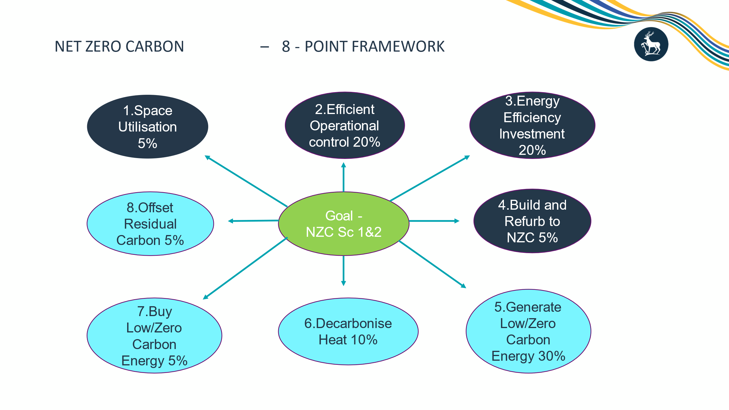

**Appendix Two**

