**University of Surrey Suicide Prevention Strategy 2024-27**

In 2023, the University of Surrey Wellbeing Strategic plan was launched, this document aimed to address the strategic direction for wellbeing and welfare provision for the student community, it outlined the context of increasing national concern about student mental health and used [University UK (UUK)](https://www.universitiesuk.ac.uk/what-we-do/policy-and-research/publications/features/suicide-safer-universities/main-guidance) guidance to shape roles and responsibilities for the University.

Since the launch of this strategy there has been continued dedication to wellbeing and the whole University approach , the Seamless Student Journey design principles of joined up and supportive services to enhance the wellbeing of the student population. This plan blends this whole University approach with a number of other key national and local guidance including University Mental Health Charter, outcome of the Abrahart review and local Suicide Prevention strategy and the release of the local Alison Todd guidance.

**University of Surrey’s commitment statement**

*“The University of Surrey are committed to providing education services of excellent quality to our students along with appropriate pastoral support. This means we aim to support our students in all aspects linked to their study, including their safety and wellbeing where possible. To do this, we will utilise our links with local NHS primary and secondary care settings to escalate support for students at risk from harm and embed the principles of a Suicide Safer University in our daily operations. It is important to note that, as a university, and not a statutory health service provider, we cannot and do not replicate health care services.”*

**How has the strategy been developed?**

UUK guidance outlines the links between prevention, intervention and postvention, with strategic planning and review as fundamental basics.

Throughout all national and local strategies, co-production is key. A diverse range of colleagues are involved in the development and review of the Suicide Safety strategy, many of whom would be involved after an incident related to serious self harm and suicide. 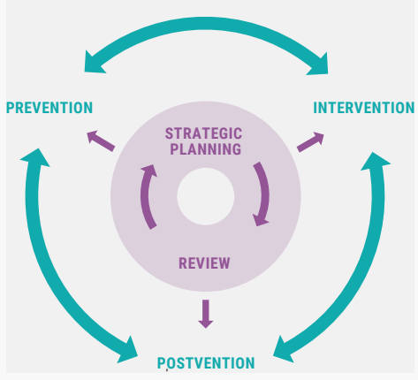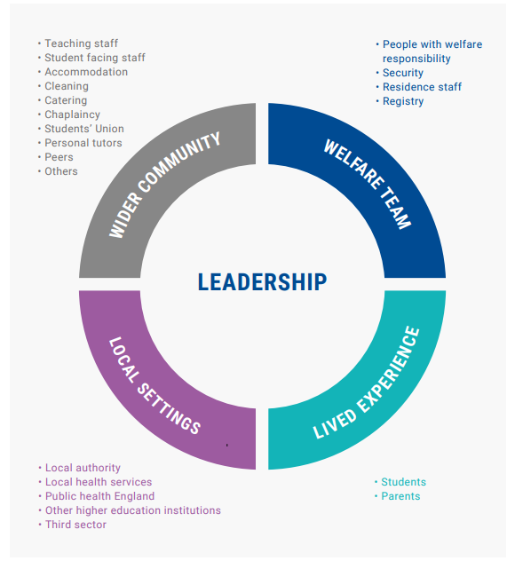

**Action Plan**

KEY

P-prevention

I-intervention

PV-postvention

|  |  |  |  |
| --- | --- | --- | --- |
| Action | Detail | Completion Date | |
| **University Wide** | | | |
| Confirm the University position on duty of care | Statement agreed and widely used in process design and principles of support | 2023 |  |
| Join University Mental Health Charter program | Join the programme for submission in September 2025 (P, I) | Sept 2025 |  |
| Health and Safety (P) | Areas of risk such as high roofs and walk way access is covered in Estate’s risk ratings (P) | Ongoing |  |
| Access to means (P) | Create a guidance document on materials that can be used for suicide. (P) | Oct 2023 |  |
|  |  |  |  |
| **Staffing** | | | |
| Review duty and administrative teams (I) | Ensure effective delivery of crisis work and a joined up, stepped-care approach | 2023 |  |
| Review out of hours service provision (P,I) | New on-call rota and service provision via ThriveWell now in place | Dec 2024 |  |
| Resourcing (P,I) | Ensure support service are apparently sourced | Sept 2024 |  |
|  |  |  |  |
| **Systems** | | | |
| Procure new Database for CWB and Disability team (P) | Create a system that joins up information in a unified records system. Simplicity will be in place by summer 2025 | 2025 |  |
|  |  |  |  |
| **Student focused work** | | | |
| Transitions (P) | Focus on transitions in and out of University and at key points during student journey, Peer Support Developments, return to studies is a key area of work, going out to and returning from placement | 2025 |  |
| Promote healthy behaviours (P) | Promote healthy behaviours, accountability and mental health within the curriculum and co-curricular activities, wellbeing workshops | 2027 |  |
| Community building (P) | Events and harmonious communal living support, restorative justice and more peer support | 2025 |  |
| Harassment/Bullying/Discrimination | Prevent and act on bullying, harassment and discrimination (P) | Ongoing |  |
| Culturally appropriate and targeted interventions (I) | Create accessible and targeted support through ThriveWell and wider services | Ongoing |  |
| Recognise signs and vulnerabilities using alert systems (I) | Use Surrey Support and other systems available to detect poor engagement, academic issues, etc | Not started |  |
| Higher risk students | Identify and support students with a higher risk of harm | Ongoing |  |
|  |  |  |  |
| **Service specific** |  |  |  |
| Deliver 24/7 student support (P,I) | SAP now available to students 24/7, ThriveWell work out of hours, Campus Safety now have a wider remit | Sept 2023 |  |
| Clarity in service/support (P) | Ensure support provision is clear and easy to understand, effective triaging | Sept 2024 |  |
| Accessible support (P,I) | Created drop in services by ThriveWell and create a safe place on campus | Sept 2024 |  |
|  |  |  |  |
| **Policies** |  |  |  |
| Trusted adult policy (P) | Emergency contact policy to be put in place for identifying and contacting students at risk | Sept 2023 |  |
| Student Death Policy (PV) | Process updated to be in line with UUK Suicide Safer Guide | Dec 2023 |  |
| Postvention process (PV) | Postvention process developed to be in line with UUK Suicide Safer Guide. Create processes to ensure support family, staff and students post incident is offered to reduce contagion and provide support. | Dec 2023 |  |
| Information sharing (I) | Improved information sharing between services, wellbeing, departmental and support services as appropriate (P) | Sept 2025 |  |
|  |  |  |  |
| **Data and research** | | | |
| Data (PV and P) | Use data via Power BI and database to support suicide prevention | Sept 2025 |  |
| The voice of the service user (P) | Conduct surveys and use the student voice to develop services | Sept 2025 |  |
|  |  |  |  |
| **Partnership working** | | | |
| NHS and local charities (P,I) | Work with NHS partners and those from charities and third sector to support wellbeing and MH, SSP | April 2025 |  |
| NHS protocols (P,I) | Develop and enhance existing protocols with NHS and primary care, work on funding projects | April 2025 |  |
| Local suicide prevention partnership group (P, I) | Work with and sit on the group with the Surrey Suicide prevention partnership group | Dec 2024 |  |
|  |  |  |  |
| **Training** | | | |
| Staff training in wellbeing and mental health (P) | Wellbeing matrix in place now and reviewed annually, ensure compliance | May 2023 |  |
|  |  |  |  |
| **Communications** | | | |
| Social media (P) | Increased use of social media to raise awareness of support, reduce stigma | Nov 2024 |  |
| Compassionate communications (P) | Create a compassionate communication guidance document and cascade, hold annual reviews. | Oct 2024 |  |
| Raise awareness of MH and suicide (P) | Through campaigns, using Let’s Talk and other methods of communication | Nov 2024 |  |
| Develop suite of communications | For prevention and postvention, including external comms support | Dec 2024 |  |
|  |  |  |  |
| **Learnings** | | | |
| Report to the national suicide statistics (PV) | Report any serious self harm or suicide to the national data base |  |  |
|  |  |  |  |