





Scope 3 Emissions Accounting Report
Authored by University of Surrey Sustainability Team

September 2023

Table of Contents

List of abbreviations & definitions i
Executive Summary 1
Scope 3 emissions 2
Purchased goods and services 3-6
Business travel 7
Employee commuting 8-9
Homeworking 9
Student commuting 10-11
International student inter-term travel 12-13
Domestic student inter-term travel 14
Water & wastewater 15
Fuel & energy related activities 16
Downstream Leased Assets 17
Exclusions & Omissions 18

List of Abbreviations & Definitions
i
Abbreviations
CO2 Carbon dioxide
CO2e Carbon dioxide equivalent
DEFRA Department for Business, Energy & Industrial Strategy
EAUC Environmental Association for Universities and Colleges
EFCS Estates Facilities & Commercial Services
GHG Greenhouse gas/gases
HESA Higher Education Statistics Agency
HESCET Higher Education Supply Chain Emission Tool
Kg Kilogram
Km Kilometres
M&T Monitoring & targeting
T Tonnes
Tco2e Tonnes of carbon dioxide equivalent
T&D Transmission & Distribution
WTT Well-to-Tank

Definitions
Carbon dioxide equivalent (CO2e), each greenhouse gas has a different global warming potential for a given quantity of gas. CO2e refers to the number of metric tons of CO2 emissions with the same global warming potential as one metric ton of another greenhouse gas. It is a “catch-all” term for quantity of greenhouse gases, expressed as carbon.
Conversion factor, a number that converts activity data into emissions, e.g. km of distance travelled, £ of goods purchased, or kg of waste produced to tco2e released.
Direct emissions, emissions directly released by the operations of the reporting company, i.e. in the combustion of fuels.
Indirect Emissions, emissions caused as a consequence of the operations of a company, but released at sources external to that company.
Net Zero Carbon, a commitment by a company to achieve a carbon footprint of 0 tco2e by a given year and in a given set of scopes.
Scopes, carbon emissions released by a company are split across three “scopes” or categories, which separates them by cause.
Scope 1, direct emissions released by direct combustion, including burning gas, using vehicle fuel, and leaking refrigerant.
Scope 2, indirect emissions released in the generation of purchased electricity, heat and steam.
Scope 3, indirect emissions occurring from all other sources, including purchased goods, commuting, business travel, waste and water.
Supply chain, the sequence of processes and companies involved in the production and distribution of a commodity.
Executive Summary
This report was completed by the University of Surrey Sustainability Team, which sits within Estates Facilities and Commercial Services (EFCS). The University has historically had a good understanding of its Scope 1 and 2 emissions, but this report marks the first full account of its Scope 3 emissions.

This report follows the accounting guidelines set out in the GHG Protocol and includes university specific emissions such as student inter-term travel. Efforts have been made to consider all categories of Scope 3 emissions laid out in the GHG Protocol accounting standard, with reasoning presented where a category could not be sufficiently accounted for.

The University of Surrey has committed to Net Zero Carbon by 2030 across Scopes 1 and 2, and to an effort to reduce Scope 3 emissions. This report accounts for Scope 3 emissions across two years – 2018/2019 and 2021/2022 - noting methodology and data reliability, and presents recommendations for improvement in both data collection and emission reduction. 2018/2019 has been taken as a baseline year, as it is the most proximate year prior to the effects of the Covid-19 pandemic, and is therefore deemed representative of the University’s typical annual activities.

Figure 1 shows the total emission profile of the University for the baseline year 2018/2019.
Scope 3 emissions total 83,110tco2e, over 4x larger than scope 1 & 2 combined at 18,649tco2e. The proportional enormity of scope 3 emissions is consistent with other institutions in the UK higher education sector. For example, the University of Salford’s scope 3 emissions account for 86% of their total emission profile, while for the University of Oxford, scope 3 emissions comprise 84%. This number is slightly lower for the University of Surrey at 77%, partially explained by the omission of student commuting in scope 3 accounting due to data shortages.

From 2018/2019 to 2021/2022, Scope 3 emissions have been reduced from 83,110tco2e to 68,964tco2e, due primarily to a reduction in spending on goods & services, and the introduction of hybrid working as standard, reducing emissions from staff commuting. ~9000tco2e (75%) of this reduction is attributed to reduced spending, which is thought to be a consequence of decreased university-wide activity in response to the Covid-19 pandemic. Scope 3 emissions are therefore expected to rise back to near-baseline levels before meaningful reductions are made.
Scope 3
1
Scope 1 & 2

Figure 1 – Scope 3 emissions compared to the combined scope 1 & 2 emissions for 2018/2019

Scope 3 Emissions
Upstream Categories | Downstream Categories
- Purchased goods and services | 9. Downstream transportation & distribution
- Capital goods* | 10. Processing of sold products
- Fuel & energy-related activities not in Scope 1&2 | 11. Use of sold products
- Upstream transportation & distribution | 12. End-of-life treatment of sold products
- Waste | 13. Downstream leased assets
- Business Travel | 14. Franchises
- Employee commuting** | 15. Investments
- Upstream leased assets | 16 Student Commuting***
Introduction
Scope 3 emissions are all other emissions not included in Scope 1 and 2. They are often referred to as indirect emissions. As these emissions are indirect, they occur beyond or behind the activities of the reporting company, generated by suppliers or users. Despite not directly causing these emissions, a reporting company is thought to bear partial responsibility through either procuring or providing the product or service, the use or production of which causes the associated emissions.

Scope 3 emissions are divided into upstream and downstream. Upstream emissions are those which occur “up” the supply chain – i.e., in the production of goods or services supplied to the reporting company. Downstream emissions occur “down” the supply chain, i.e., in the use of products or services supplied by the reporting company. As a Higher Education Institution, the University of Surrey is a service company whose outputs are intangible. Therefore, its Scope 3 emissions are mostly upstream. Table 1 lists all Scope 3 emission categories, including university-specific categories. Categories in grey are those not relevant to the University.

Table 1 – Scope 3 emission categories as defined by the GHG Protocol Corporate Value Chain (Scope 3) Accounting and Reporting Standard
Category 8 has been excluded as the University does not lease assets from other companies. Categories 9-12 have been excluded as the University does not produce, process, transport or distribute any sold goods for end-of-life treatment. Categories 14-15 have been excluded as the GHG protocol states these categories are intended for use by different company models.
*Capital goods have been merged with category 1 – Purchased goods and services.
**Employee commuting includes homeworking as a subcategory
***Student commuting includes inter-term travel to accommodation as a subcategory, and is not included in the GHG protocol.

2

- Purchased Goods and Services
Introduction
Purchases made on behalf of the University are recorded by finance and procurement. Placing orders is largely devolved to faculties and departments, but the end-to-end process is closely co-ordinated with the Procurement Department.
Data has been sourced from the Procurement Department, and includes £ spend per supplier across procurement codes which allow for goods and services to be categorised according to type.

Methodology
Annual university spend by Proc-HE codes provided by HESA was attained for the reporting years and analysed using the HESCET tool which uses £/tco2e conversion factors provided by DEFRA. Each procurement code to which a commodity is assigned at time of purchase is mapped to one to four corresponding DEFRA categories, each of which has an associated conversion factor determined by EEIO analysis.
Any spend associated with travel, energy, waste or water are removed to avoid double counting. The HESCET tool divides emissions first into 11 high level categories, then into 21 more specific categories.
2018/2019
Category | Tonnes CO2e 18/19
Laboratory/Animal House Supplies & Services | 16,694
Estates & Buildings | 15,923
Computer Supplies & Services | 12,305
Professional & Bought-in Services including consultancy | 8738
Audio-Visual & Multimedia Supplies and Services | 2528
Telecommunications | 1485
Non Influenceable Spend | 1438
Catering Supplies & Services | 1367
Medical, Surgical, Nursing, Dentistry Supplies & Services | 1167
Library & Publications | 1059
Furniture, Furnishings & textiles | 1059
Stationery & Office Supplies | 598
Facilities Operations | 513
Health & Safety & Security | 496
Workshop & Maintenance Supplies (including Engineering) | 483
Agricultural/Fisheries/Forestry/Horticultural/Oceanographic Supplies & Services | 299
Printing, Reprographics and Photocopying | 169
Vehicles, Fleet Management (Purchase, Lease, Contract Hire) | 35
Sports Science, and Recreation | 31
Janitorial & Domestic Supplies & Services | 31
Museums and Art | 0
Total | 66,419
Table 2 – Scope 3 emissions by procurement category for 2018/2019
Emissions for 2018/2019 are 66,419 tco2e.

2021/2022
 | Tonnes CO2e 21/22
Laboratory/Animal House Supplies & Services | 18,986
Estates & Buildings | 4070
Computer Supplies & Services | 15,091
Professional & Bought-in Services including consultancy | 8738
Audio-Visual & Multimedia Supplies and Services | 1933
Telecommunications | 390
Non Influenceable Spend | 622
Catering Supplies & Services | 1034
Medical, Surgical, Nursing, Dentistry Supplies & Services | 1193
Library & Publications | 1974
Furniture, Furnishings & textiles | 782
Stationery & Office Supplies | 273
Facilities Operations | 0
Health & Safety & Security | 772
Workshop & Maintenance Supplies (including Engineering) | 584
Agricultural/Fisheries/Forestry/Horticultural/Oceanographic Supplies & Services | 253
Printing, Reprographics and Photocopying | 232
Vehicles, Fleet Management (Purchase, Lease, Contract Hire) | 9
Sports Science, and Recreation | 0
Janitorial & Domestic Supplies & Services | 62
Museums and Art | 0
Total | 56,997
Table 3 – Scope 3 emissions by procurement category for 2021/2022

Emissions for 2021/2022 are 56,997tco2e

Across both years, the most impactful categories are laboratory supplies, estates & buildings, computer supplies, and professional services.

3
A Closer Look – 2018/2019, 66,419tco2e

16694
8738

15026
12305

This analysis reiterates the impact of lab equipment, construction, IT, and business services.
Computer supplies and services dominate the wider IT category.

4

This category contributes the largest amount of carbon to the supply chain of the University. It has been disaggregated below, containing only the subcategories which contribute >100tco2e.
Laboratory supplies & services - 16,694tco2e

1472
9315
2973

Over half of the carbon generated by this category stems from capital lab equipment – likely expensive, specialised, long-life items. This is followed by laboratory consumables, examples of which include gloves and pipettes, and are typically few or single-use disposable items.
This commodity area is supplied by over 300 suppliers, but only 37 suppliers contribute >100tco2e. The top 5 suppliers contribute 25% of the category’s carbon.
The purpose of a piece of capital equipment is to provide a specialist service repeatedly or intermittently over a long period of time, while consumables and disposables are less specialist, and are used briefly before being replaced. As the two highest impact subcategories represent starkly different commodity types, a multi-pronged approach is necessary to reduce emissions. i.e. capital equipment impact may be best addressed by leasing/renting, focusing on whole-life costing, and considering reparability, while consumables can be targeted by encouraging asset management, sharing, and behaviour change of users.

5
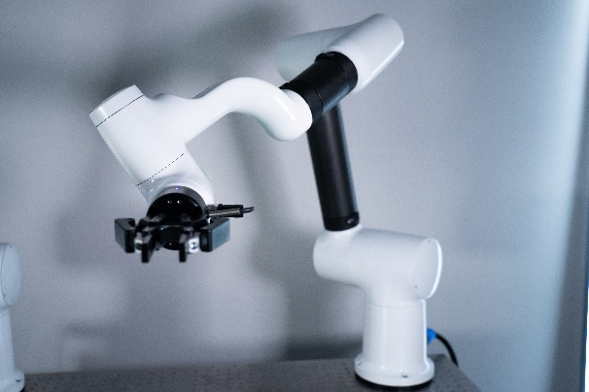

Data Reliability - Medium
Data is assigned to a code by the purchaser, so there is uncertainty in the accuracy of allocation. Furthermore, the spend method itself has many disadvantages. Categories are highly aggregated, leading to dissimilar items being assumed to have equal impact per £ spend. It also assumes a higher spend correlates to a greater environmental impact and vice-versa. However, due to the close tracking of spend, the data can be thought to be complete, lending it value in macro-analysis.

Supplier specific data should be collected for as many suppliers as possible, prioritising those with the biggest impact, done by either distributing questionnaires or through a supplier engagement tool. Some suppliers may be able to provide an itemised list of purchases along with their carbon impacts. Others can provide their total Scope 1&2 emissions along with the University’s spend as a percentage of their total revenue each year, creating a supplier specific conversion factor.

Recommendations
- Achieve Level 3 in Flexible Framework
- Produce and distribute sustainability impact assessments for relevant commodity areas.
- Implement asset management for IT
- Request emission information during capital project tender
- Introduce sustainable procurement policy to require whole-life costing, value for money, and emission data from suppliers.
- Set improved metrics for single-use plastic reduction, particularly in labs.
- Gain LEAF accreditation across labs

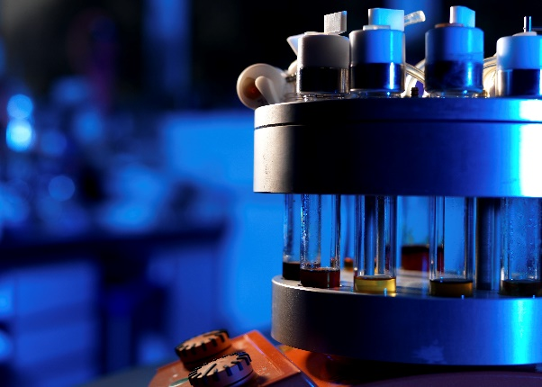
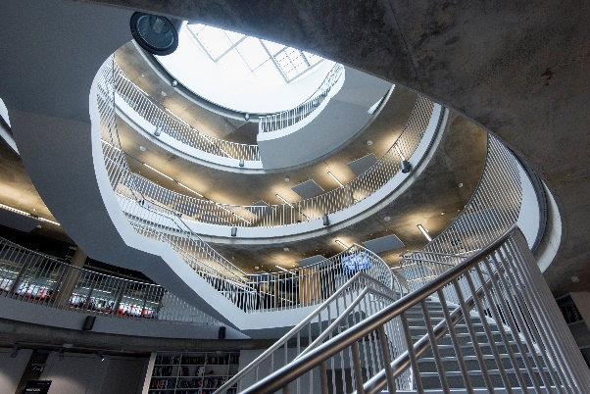
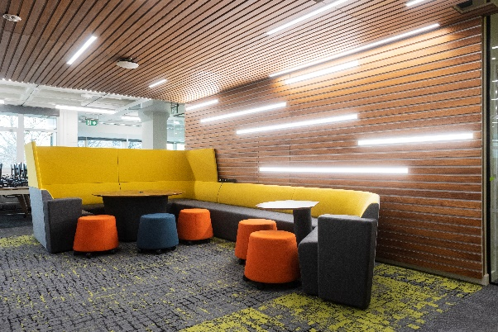
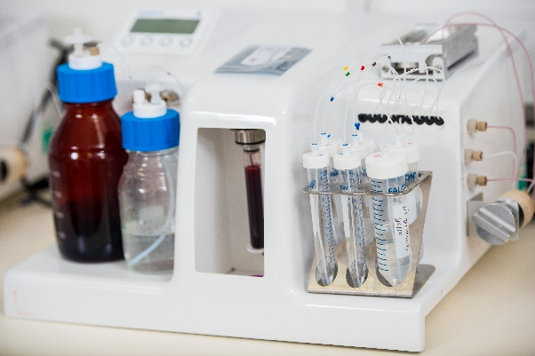

6
- Business Travel
Furthermore, fewer than 0.5% of staff account for over 10% of all business travel emissions, and 7% of all hotel stays.

Figure 2 – Scope 3 emissions by business travel category for 2021/2022

Data Reliability - Medium
Data for 2021/2022 is considered highly reliable as travel is tracked to the mile. Some travel may be unaccounted for due to short domestic rail or bus journeys not being booked through the Clarity system, though the carbon emissions associated with these journeys are considered negligible.
Data for 2018/2019 is considered of low reliability due to using financial estimations.
All future business travel undertaken will have mode and mileage tracked.

Recommendations
- No domestic flights.
- No flights to Paris or Brussels.
- Develop and distribute a travel hierarchy.
- Ensure all travel is tracked.
- Introduce offsetting options for necessary air travel, following a verified offsetting scheme.
- No first class flying, limit flying above economy class.
- Influence specific high impact travellers.

Introduction
This category covers all carbon emissions associated with travel conducted by staff and postgraduate research students on behalf of the University for business purposes, which is paid for by the University, and which is conducted in non-University owned vehicles.
This category does not include inter-term student travel or travel to and from placements.

Methodology
As of 2021, all business travel is conducted through Clarity, a business travel agency which provides carbon emission reports from air travel, rail travel, and hotel stays. Mode and distance of travel are recorded in detail, then multiplied by the relevant DEFRA conversion factors.

Prior to 2021, only financial data is held. The HESCET tool features procurement codes for all relevant categories of business travel, but suffers from overestimation. Therefore, data was validated against 2021/2022 data by multiplying the tco2e figure of 2021/2022 by the multiplicative factor between each year’s business travel spend. This provides a more valid figure than the direct value given by the HESCET tool.

Performance
2018/2019
Emissions for 2018/2019 are 1894 tco2e. Further disaggregation for this year is unlikely to lead to valid results due to the methodology.

2021/2022
Emissions for 2021/2022 are 891 tco2e.
Figure 2 disaggregates emissions into subcategories and shows that long-haul flights are the largest source. By far, flights are the largest source of emissions generally for business travel, accounting for ~95%.

7
- Employee Commuting
Introduction
This category covers all carbon emissions associated with travel conducted by employees between their homes and the University for the purpose of conducting work for the University.

Methodology
2018/2019
To date, the only employee travel survey conducted was carried out so in June 2020, and had 836 responses. At this time, work practises had not yet commonly accommodated working from home, reflected in the 4.4 average weekly commutes per person in the survey’s results. Therefore, the survey results are deemed an acceptably representative proxy of commuting in 2018/2019. Average distances and percentage of travel by car, bus and rail have been applied to verified staff numbers as of the end of 2018/2019. No data is available on bicycles or motorbikes. Figures are then multiplied by the relevant DEFRA conversion factors. As per the recommendation of the GHG protocol, a figure using the average data has also been prepared using average commuting data in the Guildford area.

2021/2022
Since 2021, all University car parks have been monitored by Total Parking Solutions, a service which monitors all visits to the campuses. This data has been used to determine number of car journeys. Rail and bus journeys, along with distance, have been estimated using the 2020 survey data, proportional to the remaining commutes unaccounted for by car park data. Total commutes per week were calculated using assumptions based on up-to-date data on staff roles. Figures are then multiplied by the relevant DEFRA conversion factors. No data is available on bicycles or motorbikes. As per the recommendation of the GHG protocol, a figure using the average data has also been prepared using average commuting data in the Guildford area.

2364
Performance
2018/2019
Emissions for 2018/2019 are 4274 tco2e. Alternatively, using the average data method, emissions are 4041 tco2e.

2021/2022
Emissions for 2021/2022 are 2675 tco2e.
Alternatively, using the average data method, emissions are 2286 tco2e. The dramatic drop in emissions from 2018/2019 to 2021/2022 is attributed to the increase in working from home (wfh), which became largely commonplace as flexible working practises were introduced during the Covid-19 pandemic and have been retained since. Figure 3 shows the emissions by mode of commute for 2021/2022 using the car park and survey data.

Figure 3 – Staff commuting emissions by transport mode for 2021/2022.

88% of staff commuting emissions – 2364tco2e - originate from car journeys. It is not known whether an appreciable portion of these are carpooled.

8
Data Reliability – Low
Calculations for both years contain a number of assumptions, chiefly that the 2020 survey data is representative of commuter habits in the reporting years. As staff are replaced and habits change, the average distance and proportion of staff using each mode of travel may change. Furthermore, there is no data on commute by foot, bicycle, motorbike or car-sharing, and there is no way to differentiate between staff and student car park use. Data should be improved by conducting more regular and comprehensive surveys.

Recommendations
- Distribute a staff commuting survey on an annual or semi-annual basis to gain a reliable understanding of commuting patterns.
- Promote car-sharing and salary sacrifice for cycling or public transport season tickets.
- Install EV charging stations on campus.
- Implement SRP electric shuttle service on a wider basis.
- Encourage flexible and remote working.

9
3.1 Homeworking
Introduction
The GHG protocol recommends the calculation of emissions from employee homeworking as an optional addition to commuting emissions. As stated in section 3, homeworking increased significantly due to the Covid-19 pandemic. As employees are using energy in the form of heating, lighting, and powering office equipment for the purpose of fulfilling work obligations, homeworking is deemed within the boundaries of the Scope 3 emissions of the University.

Methodology
For both years, the methodology used is that proposed in the EcoAct homeworking emissions whitepaper. This involves accounting for use of heating and office equipment, and accounts for changes in gas consumption based on seasonality. Assumptions for wfh days per week are made for 2021/2022 according to job role. 2018/2019 wfh days are determined by the 2020 commuter survey.

Performance
2018/2019
Emissions for 2018/2019 are 197 tco2e.

2021/2022
Emissions for 2021/2022 are 328 tco2e.

Data Reliability – Medium
Some assumptions are made about wfh days and heating usage at home, but work hours and equipment are largely standardised.

Recommendations
- Encourage only necessary equipment charging during wfh.
- Encourage general energy saving tips, such as wearing more layers in winter.
- Procure energy efficient office equipment.

10
4. International Student Inter-term Travel

Introduction
This category refers to travel taken by international students at the beginning and end of term to and from university. This category is not included in the GHG protocol, but reasonably falls within the boundaries of a university’s Scope 3 emissions, and is included under category 9: Downstream transportation and distribution in the EAUC’s standardised carbon reporting guidelines document.

Methodology
No survey has been completed concerning student travel habits, so frequency of travel must be assumed. This methodology assumes one return journey for new intake students from country of origin. More journeys are not included as it is not known to what extent international students return to country of origin through their studies between terms and years. Intra-term travel is considered travel for leisure, and therefore falls outside the boundaries of the University’s emissions.
It should be noted that using this methodology provides only the minimum probable emissions from this category and is likely an underestimation, but constitutes the most reliable approach given the available data.
Data has been collected from the Student Registry team concerning country of origin of all students per academic year. One return journey from the largest international hub airport of each country to Heathrow has been assumed, followed by one coach journey per student from Heathrow to University campus. Results are multiplied by the relevant DEFRA conversion factors, which distinguishes between emissions from domestic, short-haul, and long-haul flight.

Performance
2018/2019
Emissions for 2018/2019 are 5188 tco2e.

2021/2022
Emissions for 2021/2022 are 3848 tco2e.

The reduction in emissions between years is due to a decrease in international student numbers post-Covid-19
Figure 4 shows the emissions from Europe vs non-Europe international student travel for 2018/2019.
Figure 4 – Europe vs non-Europe emissions from international student travel, 2018/2019

Emissions from flights from non-Europe countries are higher by a factor of 10. This difference increases in 2021/2022 to a factor of 20.
Figure 5 shows the top 10 countries by emissions for the year 2018/2019

Figure 5 – Top 10 countries by emissions from international student travel, 2018/2019

Countries in Asia contribute most significantly to emissions in this category, due to a combination of large distance and high student population.

11

Data Reliability – Medium
Assumptions are made surrounding international students’ frequency of travel, along with the origin airport. However, student numbers per country are closely tracked, and the methodology likely provides a valid minimum figure. Greater data reliability could be achieved by surveying travel habits of international students.

Recommendations
- Create and distribute a questionnaire to better understand international student travel frequency.
- Offer incentives to students to stay on campus out of term time in form of events.
- Encourage students to travel less often.

12
4.2 Domestic Student Inter-term Travel

Data Reliability – Medium
Assumptions are made surrounding domestic students’ frequency of travel, along with the mode of travel. However, student numbers and postcodes are closely tracked, and the methodology likely provides a valid minimum figure. Greater data reliability could be achieved by surveying inter-term travel habits of domestic students.

Recommendations
- Create and distribute a questionnaire to better understand domestic student travel frequency.
- Offer incentives to students to stay on campus out of term time in form of events.
- Encourage students to travel less often.
Introduction
This category refers to travel taken by domestic students at the beginning and end of term to and from university. This category is not included in the GHG protocol, but reasonably falls within the boundaries of a university’s Scope 3 emissions, and is included under category 9: Downstream transportation and distribution in the EAUC’s standardised carbon reporting guidelines document.

Methodology
No survey has been completed concerning student travel habits, so frequency of travel must be assumed. This methodology assumes one return journey for new intake students from postcode of origin. More journeys are not included as it is not known to what extent domestic students return to postcode of origin through their studies between terms and years. Intra-term travel is considered travel for leisure, and therefore falls outside the boundaries of the University’s emissions.
It should be noted that using this methodology provides only the minimum probable emissions from this category and is likely an underestimation, but constitutes the most reliable approach given the available data.
Data has been collected from the Student Registry team concerning postcode of origin of all students per academic year. One return journey from the origin postcode to Stag Hill campus is assumed. Results are multiplied by the DEFRA conversion factor for “average car.”

Performance
2018/2019
Emissions for 2018/2019 are 148 tco2e.

2021/2022
Emissions for 2021/2022 are 142 tco2e.

13
5. Upstream Transportation & Distribution

Recommendations
- Require suppliers to provide estimations of total emissions from transport of their goods, either on an itemised basis or as an average

Introduction
This category refers to transportation & distribution of goods purchased by the University in the given reporting years. The emissions arise from the combustion of vehicle fuel during transportation, and are therefore the Scope 1 & 2 emissions of the distribution providers.

Methodology
The University wide spend on transportation of goods was obtained and used with the HESCET tool codes QC and QD – courier services and freight carriage & haulage services. The resulting emissions have been subtracted from section 1. – Purchased Goods & Services - in order to avoid double counting.

Performance
2018/2019
Emissions for 2018/2019 are 106 tco2e.

2021/2022
Emissions for 2021/2022 are 205 tco2e.

Data Reliability – Low
It is unclear whether the methodology used accounts for all transport of delivered goods, or only dedicated courier and freighting services. The factors included in the HESCET tool were created by the Centre for Sustainability Accounting, a group which no longer exists, and therefore this cannot presently be determined. Therefore, this carbon figure may only represent a minimum. Furthermore, this methodology is subject to the same shortcomings as mentioned in category 1 – namely the aggregation of similar goods and services into one figure – a consideration which is especially pertinent for business services, many of which (including freighting) share a generic “business services” conversion factor.

14
- Water & Wastewater
Performance
2018/2019
Emissions for 2018/2019 are 153 tco2e for water, 268 tco2e for wastewater & trade effluent, and 421 tco2e total.

2021/2022
Emissions for 2021/2022 are 22 tco2e for water, 75 tco2e for wastewater & trade effluent, and 97 tco2e total.

The reduction in emissions from water is due to a combination of factors, chiefly the introduction of the Stag Hill borehole. Other factors which also contribute to the reduction in wastewater and trade effluent emissions include improved leak detection, water saving measures, and a large reduction in the carbon intensity of UK water and wastewater.
The Stag Hill borehole led to a reduction in emissions from water use on Stag Hill campus of 85%.

Data Reliability – High
Water use is monitored closely by accurate metering. Though some estimations are made, these are generally in low consumption sites. Wastewater and trade effluent data are less reliable, but percentages are thought to have been calculated accurately by Thames Water.

Recommendations
- Ensure installation of borehole in Manor Park campus is completed.
- Perform preventative maintenance in the form of leak detection and descaling.
- Use water consumption sensors in accommodation showers.
- Conduct a wastewater audit to verify data.
- Incorporate water efficient fixtures, water recycling, and rainwater harvesting into new construction projects.
- Encourage behaviour change among staff and students to reduce water consumption.
Introduction
This category refers to emissions arising from the treatment and transportation of all water used in the operations of the University. Also included are all emission associated with transport and treatment of wastewater and trade effluent arising from use in the operations of the University. This includes water used in, and wastewater produced in, university-owned accommodation. In 2021 the University completed the installation of a borehole which extracts water locally and feeds the entire Stag Hill site. The borehole is powered by purchased electricity, and therefore its emissions are reported under Scope 2, and have been deducted from this section.

Methodology
The University collects data on water consumption from metering, the majority of which reports automatically to the University’s monitoring & targeting software, SIGMA. The remaining meters which do not automatically report are checked and recorded manually. A few sites with low consumption are not metered. Their consumption is based on the invoiced amount from Thames Water, the local water provider.
Wastewater and trade effluent are not metered, but are charged by consumption as determined by Thames Water as a certain percentage of a given site’s water consumption, as quantity, drainage, and treatment differs per site. Each site’s wastewater and trade effluent percentage is then applied to the water consumption figures to determine consumption.
Consumption is then multiplied by the relevant DEFRA conversion factors. Trade effluent is calculated using the wastewater conversion factor.

15
7. Fuel & Energy Related Activities
Introduction
This category refers to emissions arising from the production and transmission of fuels and energy purchased and consumed by the University. It does not contain those emitted by combustion or purchase of fuel. It contains three sub-categories – emissions from transmission & distribution losses of purchased electricity, well-to-tank emissions of purchased electricity, and well-to-tank emissions of purchased fuels (natural gas). WTT emissions refer to those resulting from the extraction, production, and transportation of fuels consumed in the generation of electricity or fuel which is later consumed or combusted by the reporting company.

Methodology
The University collects data on electricity and fuel consumption through close metering, automatically reported to the University’s monitoring and targeting package. This consumption data is included in the University’s annual Scope 1 & 2 emissions reports. DEFRA provides conversion factors for T&D losses and WTT emissions, by which consumption has been multiplied.

Performance
2018/2019
Emissions for 2018/2019 are 3658 tco2e. Transmission and distribution losses of electricity consumption account for 800 tco2e.
WTT emissions from electricity consumption account for 1314 tco2e.
WTT emissions from natural gas consumption account for 1545 tco2e.

2021/2022
Emissions for 2021/2022 are 3437 tco23.
Transmission and distribution losses of electricity consumption account for 572 tco2e.
WTT emissions from electricity consumption account for 1496 tco2e.
WTT emissions from natural gas consumption account for 1369 tco2e.

It should be noted that between 2018/2019 and 2021/2022, electricity consumption decreased by 12.2%, and natural gas consumption decreased by 24.3%. This is not reflected in the carbon figures due to an increase in the relevant DEFRA conversion factors for T&D losses and WTT emissions. Figures 6&7 show the difference between energy related scope 3 emissions and between energy consumption across years respectively.

Figure 6 – T&D & WTT emissions across reporting years

Figure 7 – Electricity & Gas consumption across years
Data Reliability – High
Energy use is monitored closely by accurate and well distributed metering, most of which report on an automated, half-hourly basis. Due to this close monitoring, reliability is considered high.

Recommendations
Reductions in these emissions are only feasible through two approaches: reduction of consumption and adoption of a greater proportion of renewable energy.

16
8. Downstream Leased Assets
Data Reliability – High
Energy use in leased buildings is monitored with the same accuracy as University-operated buildings, so data reliability is thought to be high.

Recommendations
As with the previous category, reductions in these emissions are only feasible through two approaches: reduction of consumption and adoption of a greater proportion of renewable energy.

17
Introduction
This category refers to emissions arising from the operation of assets owned by the University and leased to external companies, including the University of Surrey’s Student Union (USSU). The University’s leased assets are limited to premises, and therefore the emissions from this category are the result of energy use in those premises.
The University leases a number of premises to independent operators for a diverse set of purposes, including student accommodation, office space, event/entertainment space, commerce and healthcare. The total scope 1 and 2 emissions of each operator within their leased space constitutes this section of scope 3.

Methodology
The University collects data on electricity and fuel consumption for each of its commercial operators and external partners in leased assets. Buildings are monitored by metering much like in University operated buildings, and data is reported through the M&T package. Electricity and gas consumption for all leased premises during the reporting years have been collected and multiplied by the relevant DEFRA conversion factors.

Performance
2018/2019
Emissions for 2018/2019 are 805 tco2e.
Electricity consumption accounts for 417 tco2e.
Gas consumption accounts for 388 tco2e.

2021/2022
Emissions for 2021/2022 are 344 tco2e.
Electricity consumption accounts for 195 tco2e.
Gas consumption accounts for 149 tco2e.

The reduction from 2018/2019 - 2021/2022 is partially due to reduced consumption, but is mostly attributed to a change in operation of two accommodation blocks, one becoming out of use, the other ceasing to be leased.

18
Exclusions & Omissions
Due to shortages in available data, one category which does apply to the operations of the University – and which therefore should be accounted for – has had to be omitted. This is category 5, Waste Generated in Operations. A university specific category – student commuting – has also had to be omitted.

Waste has been omitted as currently the University does not receive granular enough data around the treatment of its waste. In order to calculate emissions, the mass of each waste type (as determined by DEFRA categories) treated by a given method e.g. open-loop recycling, energy from waste, must be ascertained. Currently, the University’s waste contractor does not report according to waste categories for which conversion factors are available, and does not report treatment by waste type, only treatment of the waste as a whole, the carbon implications of which differ.

As for student commuting, until a student travel survey is created and distributed, it will not be possible to account for this category. Parking permits do not differentiate between staff and students, while bus use numbers include staff and members of the public. The University routes are travelled by public buses which, in addition to the campuses, service the surrounding local area, and are used frequently by non-students. While data is available on number of bus passes held, this does not give adequate information on either frequency of travel by pass holders, or the remaining frequency of journeys (which likely account for a majority) conducted by students without a pass.

Of the ~23,500 students who have logged their term time address, ~16,000 (68%) live within the GU postcode area, which is confined mostly to Surrey. 12,000 of this number (51% of total), live within the GU2 postcode area (that of both university campuses), and therefore are likely to walk, cycle or occasionally use the bus to commute. For students outside the GU postcode area, the average distance from campus is 35km – a number skewed by outliers who are likely distance learners, or those who have erroneously logged home address as term-time address. Until this is clarified, and the commuting habits of these students are elucidated, no appropriate analysis can take place.

An additional subcategory related to student commuting has also been omitted – student placement travel. Some courses in the Faculty of Health and Medical Sciences involve mandatory placements at clinics and hospitals, requiring students to travel around the UK to fulfil course requirements. Most of these placements are local to the Surrey area, and anecdotal consultation suggests students who do travel far are likely to stay at accommodation for the duration of their placement. Data is available on location of placements per student, but commuting distance and mode are unknown. Therefore, an analysis of this category would involve too many assumptions to produce meaningful results. As with student commuting generally, this would be best addressed by the creation of a student commuting survey.

Other student placements – i.e., those undertaken as a professional training year (PTY) – are thought to be outside the boundaries of the University’s emission profile, as while a student who has selected this option must fulfil its requirements, it is an optional pursuit whose associated emissions are thought to be the responsibility of the hosting company who determines the travel demands during the placement, as students undertaking a PTY are primarily employees of the hosting company for its duration.

