**TravelCert: Instructions for Organisations and their Users.**

The TravelCert website, which allows users to log their upcoming travel and download insurance Cover Notes, has been updated. The new system will be launching in June and we need to tell you what is changing and the actions you will need to take to ensure you can continue to use the system.

**Registration and User Profile**The biggest change for TravelCert users is the requirement to register and create a User Profile. This change has been brought about by the enhanced security features of the new site, which are required under Data Protection regulations.

**To create a User Profile you must have access to a University of Surrey domain email address.**You cannot create a profile using webmail providers such as gmail, hotmail, yahoo etc. as the system uses the University of Surrey domain name to validate that the attempt to create an account is genuinely linked to your organisation.

You will need to make sure you have access to your University of Surrey email account in order to receive registration emails and One Time Password (OTP) details or you will not be able to register and log in. If you do not have access to a University of Surrey email account please contact the University of Surrey Insurance Office ([insurance@surrey.ac.uk](mailto:insurance@surrey.ac.uk)).

**TO REGISTER**

1. Go to <https://travelcert.ajg.com/>
2. 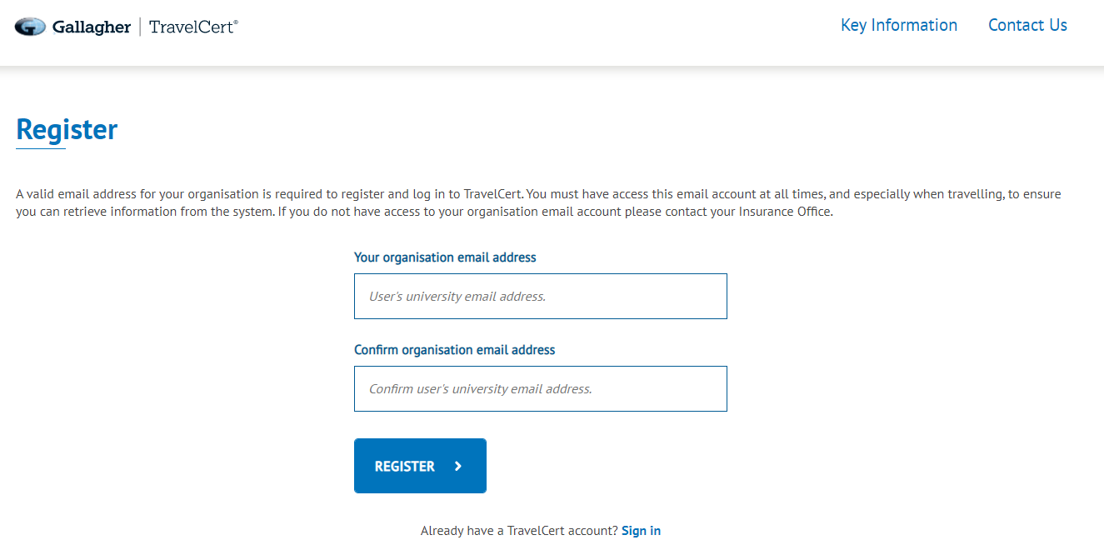Click on “Register”
3. Enter your organisation email address to receive a registration link.
4. Check your emails and click on the link within the email you receive from TravelCert – make sure you check your spam / junk folder if the email hasn’t arrived within a few minutes.
5. The link will take you back to the TravelCert website where you can now set up your profile.
6. Create a password, you will need this to log in each time you access TravelCert. Please take notice of the guidance on the website regarding the use of special characters to create your password.
7. From now on, every time you log in you will be sent a one-time passcode (OTP) to your registered email address, which you will need to enter to access your account. The passcode is valid for 15 mins, after which time if you haven’t used it to log in you will need to request another one.

**CREATE YOUR PROFILE**

The first time you log in you will need to create your Profile and add at least one Emergency Contact. Follow the instructions on the screen to add your details.

Once you have done this you will not need to enter your details again, unless you wish to update any of your details, which you can do from within your account.

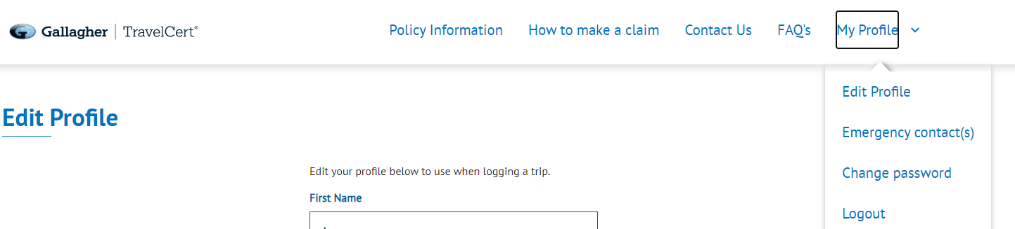You can also edit your Emergency Contacts and change your password.

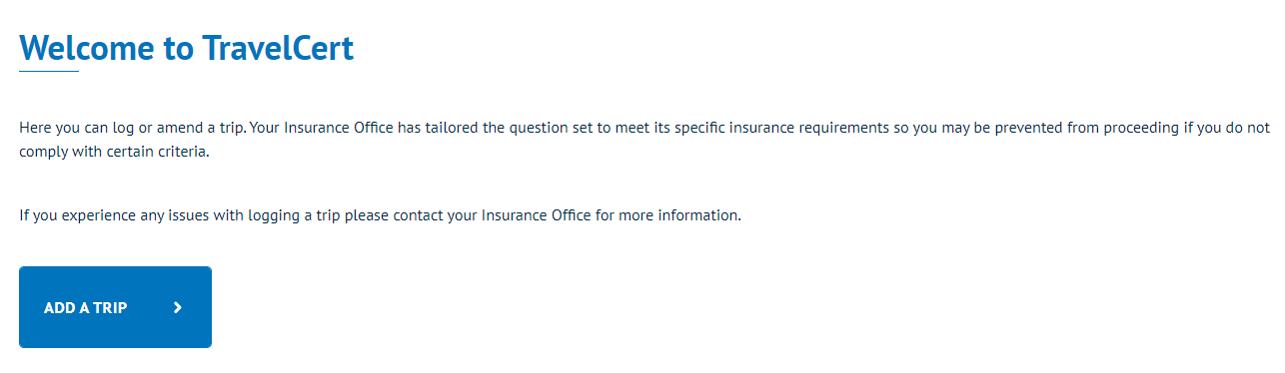You are now ready to start logging trips.

**ADDING A TRIP**Add your start and end dates, select the destination from the drop down list and click “Add Destination”. Trips cannot be backdated and can only be of a maximum 12 months duration.

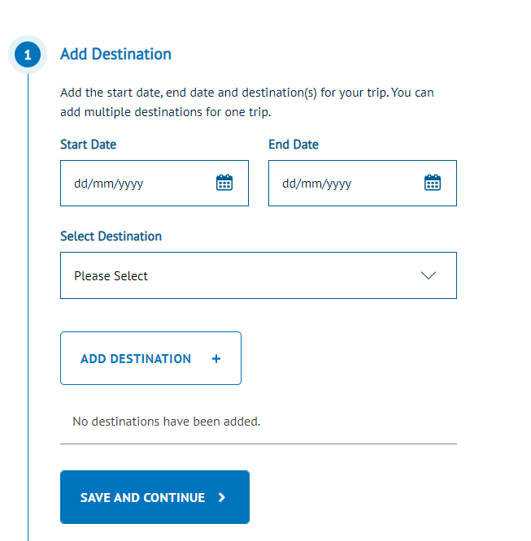

**MULTI DESTINATION TRIPS**  
If you are logging a multi- destination trip repeat the above for each leg of your trip.

**Note**: multi-destination trip dates must run concurrently, if there are any gaps then you must log as a separate trip.

**RESTRICTED DESTINATIONS**  
Travel is not permitted to some destinations under the terms of your organisation’s travel insurance policy. If you receive the notification below, please contact your Insurance Office.

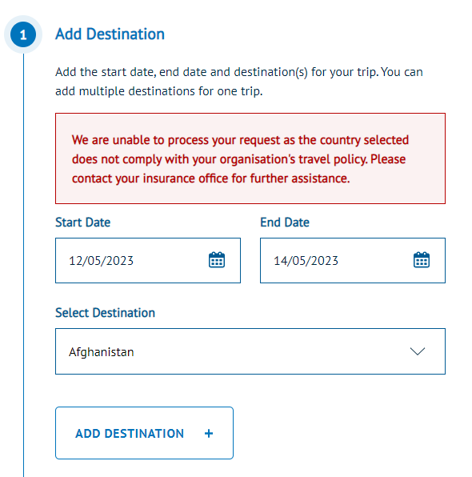

**COMPLETE QUESTIONS**  
Continue to work your way through the question list which depending on your University’s set up may include:

* Medical
* Risk & Assessment
* Purpose of trip
* Equipment
* Trip approval
* Additional travellers

If any of your responses do not comply with your organisations Travel Policy you will be referred to your Insurance Office.

**ADD EMERGENCY CONTACT DETAILS**  
Select you chosen Emergency Contact from the drop down list or add a new one for this trip only.

**SUBMIT DETAILS**  
Click on “SAVE AND CONTINUE” to log your trip

If your trip has been logged successfully, you will receive an email confirmation, which includes a link to download your certificate. You can also download your document at any time from your “My Trips” dashboard.

**ACCESSING / EDITING YOUR TRIP**You can access and edit your trip details and certificate at any time from your account home page under “MY TRIPS”:

